**Chapter 2:**

In this chapter, you’ll create your first Flutter project to familiarize yourself with the development process. By building a simple "Hello World" app, you’ll learn the basic structure of a Flutter application and how to run it on both the iOS simulator and Android emulator. You’ll also experiment with making changes to the code and observing the results.

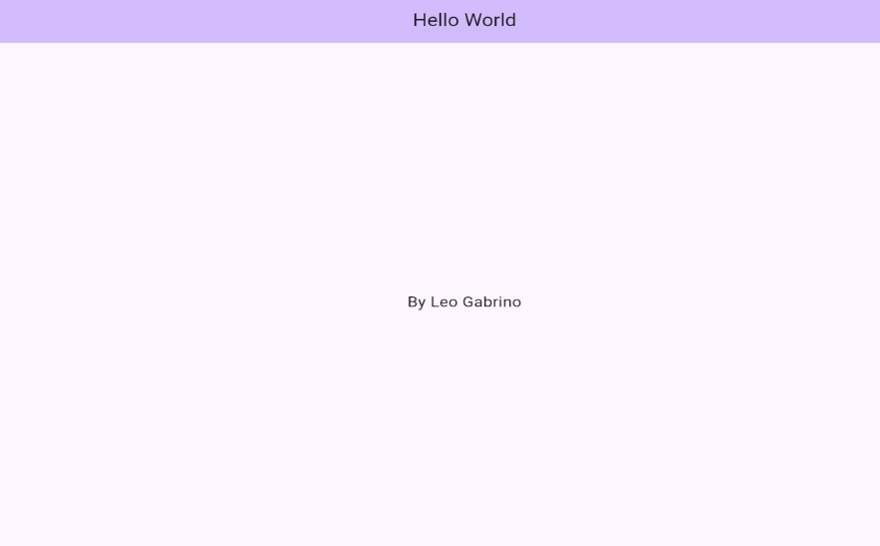The focus at this stage is not on understanding the code in detail, as the chapter aims to provide a hands-on introduction. Detailed explanations of the code and its components will be covered step-by-step in subsequent chapters. By completing this exercise, you’ll get comfortable with the workflow of creating and running Flutter applications, laying the groundwork for more complex projects later on.

